BUNAMFAN CLUSTER EXAMINATION – 2022
Kenya Certificate of Secondary Education
232/2 – PHYSICS – Paper 2

June 2022 - 2 hours

Name…………………………………Adm No……
Class…………… Date……………………………

Instructions to Candidates

- Write your name and index number in the spaces provided above.
- Sign and write the date of examination in the spaces provided above.
- This paper consists of two sections: A and B.
- Answer ALL the questions in sections A and B in the spaces provided.
- ALL working MUST be shown clearly
- Mathematical tables and silent electronic calculators may be used.
- This paper consists of 14printed pages.
- Candidates should check the question paper to ascertain that all the pages are printed as indicated and that no questions are missing.

For Examiner’s Use Only

SECTION | QUESTION | MAXIMUM SCORE | CANDIDATE’S SCORE
A | 1 – 13 | 25
B | 14 | 11
 | 15 | 12
 | 16 | 0 9
 | 17 | 10
 | 18 | 12
TOTAL SCORE |  | 80

SECTION A (25 MARKS)
Answer ALL the questions in this section in the spaces provided

- (a)Distinguish between real and virtual Image (1mark)
……………………………………………………………………………………………
……………………………………………………………………………………………
…………………………………………………………………………………………
b)A pinhole camera forms an image of size 10cm. The object is 5m tall and 20m away from the pinhole. Find the length of the pinhole camera. (2marks)
…………………………………………………………………………………………...…………
………………………………………………………………………………………………………
…………………………………………………………………………………………...…………
2.Why is it safer to carry explosive fuels in metal cans instead of plastic can? (1mark)
……………………………………………………………………………………………
……………………………………………………………………………………………
3.The figure 1 below shows a cross section of a dry cell.
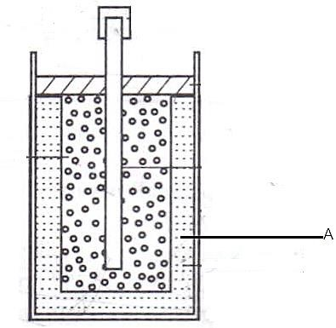Figure 1
  - Name the part labeled A (1 mark)

…………………………………………………………………………………………...…………
………………………………………………………………………………………………………
  - State the use of manganese (iv) oxide in the cell (1 mark)

…………………………………………………………………………………………...…………
……………………………………………………………………………………………………
4.a) The figure 2 below shows a soft iron bar that’s placed in a coil near a free suspended magnet.
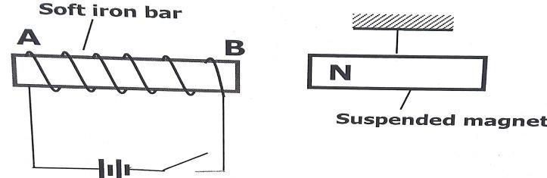
figure 2
State and explain the observation made when the switch is closed. (2marks)
…………………………………………………………………………………………...…………
………………………………………………………………………………………………………
…………………………………………………………………………………………...…………
b.) Give a reason why attraction in magnetism is not regarded as a reliable method of testing for polarity. (1mark)
………………………………………………………………………………………………………
5.Explain the termwavelength in terms longitudinal wave (1mark)
………………………………………………………………………………………………………
6.(a) State the effect of pressure on the speed of sound in air. (1mark)
………………………………………………………………………………………………………
(b) A boy stands 190m from a high wall and claps his hands. If he hears an echo1.3 Seconds later, calculate the speed of sound in air. (2marks)
………………………………………………………………………………………………………
………………………………………………………………………………………………………
………………………………………………………………………………………………………
7.Figure 3below shows an object, O placed 10 cm in front of a concave mirror whose radius, C is 40 cm.
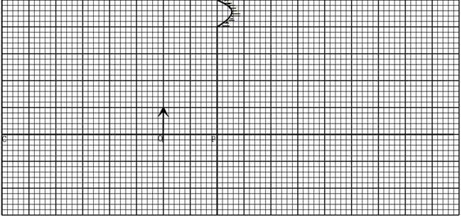
On the same figure, draw a ray diagram to show the position of the image formed. (3 marks)

8.State any factor that determine the heating effect by an electric current.
(1mark)
………………………………………………………………………………………………………

9.Figure 4 shows the table of electromagnetic. Spectrum in the increasing order of wavelengths.

P | x-rays |  | Q | Infra-red
a).Identify the radiation marked (1mark)
Q. –………………………………………………………………………………………………………
b) State the application of radiation marked P (1mark)
……………………………………………………………………………………………………
10.Light travels from glass to air as shown in figure 5. The refractive index of glass 1.5figure 5.

X
0

Air

Glass

n=5

(a) Determine angle x (2marks)
………………………………………………………………………………………………………
………………………………………………………………………………………………………
………………………………………………………………………………………………………
11.Figure 6 shows air molecules in front of a hollow, wooden box B set vibrating by a tuning fork.
Tuning fork

figure 6 Y Z
i)State the reason of mounting the tuning fork on the box which is open at one end. (1mark)
……………………………………………………………………………………………………………
…………………………………………………………………………………………………….......
ii)What is the name given to this kind of wave? (1 mark)
………………………………………………………………………………………………………

12.The figure 7 below shows an isolated negative charge placed closer to a negatively charged plate. Draw the electric field patterns. (1mark)
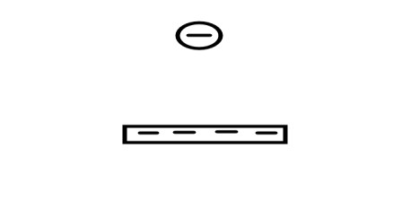figure 7

13.Kenya launched the use of optical fibres in communication recently. State why optical fibres are preferred to ordinary cables (1mark)
………………………………………………………………………………………………………
………………………………………………………………………………………………………

SECTION B( 55MARKS)

14.(a)State two ways in which the speed of rotation of a motor can be increased (2marks)
……………………………………………………………………………………………
…………………………………………………………………………………………

b)The figure 8 below shows a simple electric bell circuit

Switch
Gong

X

Hammer

Spring

Z

N

S

Y
figure 8

- Name the parts labeled.
(2marks)
- X……………………….

- Y ………………………

ii) When the switch is closed, the hammer hits the gong repeatedly. Explain why:
- The hammer hits the gong. (2marks)

………………………………………………………………………………………………………
………………………………………………………………………………………………………
………………………………………………………………………………………………………
- The hammer hits the gong repeatedly (2marks)
………………………………………………………………………………………………………
………………………………………………………………………………………………………
………………………………………………………………………………………………………

iii) If the armature is made of steel metal, it is observed that the bell will take longer to ring. Explain this observation . (1 mark)
………………………………………………………………………………………………………
……………………………………………………………………………………………………
iv) Nametwo adjustment should be done to the system to make it operate effectively with a lower voltage battery? (2mark)
………………………………………………………………………………………………………
………………………………………………………………………………………………………

15. (a) In an experiment to determine the internal resistance of a cell, the following circuit was used.
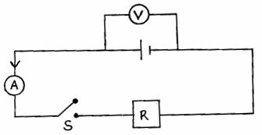

It was noted that when S is open, the voltmeter reads 1.5V and when S is closed the voltmeter reads 1.3V and ammeter reads 0.2A.
(i) Define the term e.m.f of the cell. (1mark)

……………………………………………………………………………………………
(ii) Determine the lost voltage. (1mark)

……………………………………………………………………………………………
……………………………………………………………………………………………

(iii)Determine the value of R. (2marks)
……………………………………………………………………………………………………………………………………………………………………………………………………
(iv) Determine the internal resistance of the cell. (3marks)
……………………………………………………………………………………………………………………………………………………………………………………………………………………………………………………………………………………………………………………………………………………………………………………………………

- Study the circuit below and answer the questions that follow.
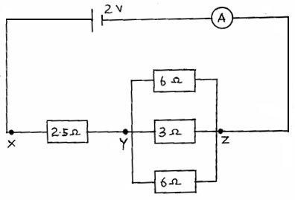

(i) Determine the effective resistance of the circuit. (3marks)

……………………………………………………………………………………………
……………………………………………………………………………………………
……………………………………………………………………………………………
(ii) Determine the p.d between X and Y. (2marks)
……………………………………………………………………………………………
……………………………………………………………………………………………
16.(a) (i)Define capacitance of capacitor (1mark)

……………………………………………………………………………………………
……………………………………………………………………………………………
(ii)A positively charged rod with a pointed end is brought near a candle flame as shownfig. 9.
Flame
fig.9

Candle

Positively
charged needle

Explain why the flame burns in the direction shown (1mark)

……………………………………………………………………………………………
…………………………………………………………………………………………

b). One of the factors which affect the capacitance of a parallel plate capacitor is the area of overlap of the plates. Name two other factors. (2marks)
……………………………………………………………………………………………
……………………………………………………………………………………………
c).Calculate the effective capacitance of the capacitors shown across points X and Y. (3marks)
60µF 30µF

X

Y

20
µF

……………………………………………………………………………………………
……………………………………………………………………………………………
……………………………………………………………………………………………

d).A capacitor was full charged to a potential of 40v. The capacitor is connected as
shown in the figure below to discharge at load resistor R. Sketch a graph to show how
the capacitor discharges with time

(2
marks
)

R

A

V

……………………………………………………………………………………………
……………………………………………………………………………………………
…………………………………………………………………………………………
17.(a)Water waves from a given source move from a deeper a shallow to end. What effect would this have on the;
(i) Frequency (1mark)
……………………………………………………………………………………………

(ii)Wavelength (1mark)
……………………………………………………………………………………………

(iii) Velocity of the wave(1mark)
……………………………………………………………………………………………
(b).The figure 10 shows wave fronts approaching a wide opening

figure 10

i)Complete the diagram to show the appearance of the wave fronts after crossing the opening (2mark)
(ii)State what would be observed on the pattern if the gap was made smaller (1mark)

……………………………………………………………………………………………
……………………………………………………………………………………………
c.) Figure 11 below shows light rays from two coherent sources S₁ and S₂ falling on screen. Dark and bright fringes are observed between A and B
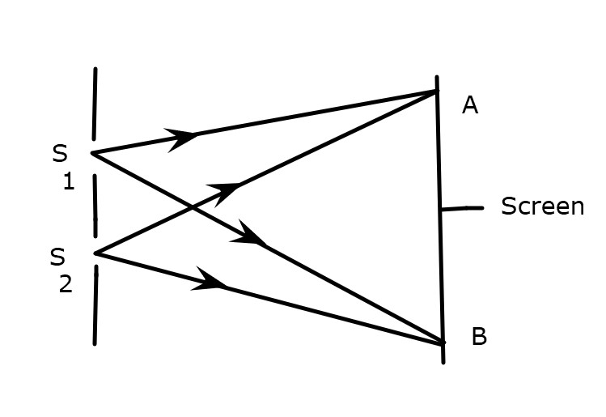 figure 11
- State the function of S₁ and S₂ (1mark)
……………………………………………………………………………………………
- State how
- Bright fringes are formed (1mk)
……………………………………………………………………………………………
……………………………………………………………………………………………

- Dark fringes are formed (1mark)
……………………………………………………………………………………………
c). Figure12below shows plane water waves incident on a plane reflector placed at an angle to the path of the waves.
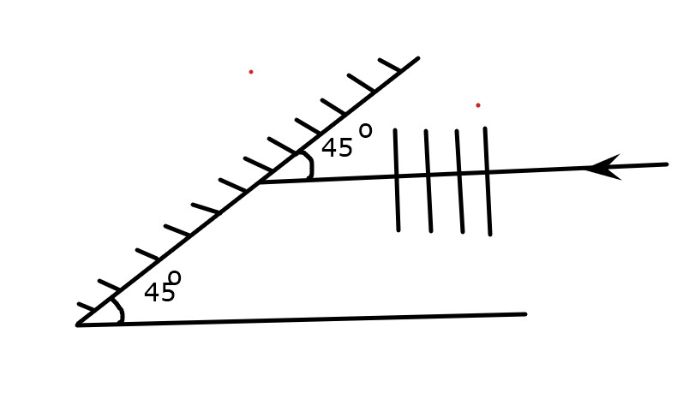

Complete the diagram to show the reflected waves (2marks)

18. (a) Define the term principal focus for in converging lens(1mark)
……………………………………………………………………………………………
……………………………………………………………………………………………
b) Sketch on a diagram to illustrate how a convex lens is used as a magnifying
glass. (3 marks)
……………………………………………………………………………………………
……………………………………………………………………………………………
……………………………………………………………………………………………
……………………………………………………………………………………………
(c) In an experiment to determine the focal length of a converging lens using lens
formula, several values of image distance corresponding to value of object distance u
were determined and a graph of magnification m against image distance
v, plotted as shown in Figure 13

The equation of the graph can be represented by the equation m =$\frac{v}{f}$-1

(i) State the significance of the gradient of the graph (1mark)

……………………………………………………………………………………………
……………………………………………………………………………………………
(ii) From the graph, determine the focal length of the lens. (3marks)

……………………………………………………………………………………………
……………………………………………………………………………………………
……………………………………………………………………………………………
……………………………………………………………………………………………
(iii) Determine the value of object distance for which the image is not magnified. (1mark)

……………………………………………………………………………………………
……………………………………………………………………………………………
(iv) An object of height 10.5cm stands before a diverging lens of focal length 20cm and a
distance of 10cm from the lens. Determine the image distance. (3 marks)

……………………………………………………………………………………………
……………………………………………………………………………………………
……………………………………………………………………………………………
……………………………………………………………………………………………
……………………………………………………………………………………………
……………………………………………………………………………………………

  - THIS IS THE LAST PRINTED PAGE

