BUNAMFAN CLUSTER EXAMINATION – 2022
Kenya Certificate of Secondary Education
232/1 – PHYSICS – Paper 1
June 2022 - 2 hours

Name…………………………………Adm No……
Class…………… Date……………………………
INSTRUCTIONS TO THE CANDIDATES:
- Write your Name, Admission Number and Class in the spaces provided above.
- Answer all the questions both in section A and B in the spaces provided below each question
- All workings must be clearly shown; marks may be awarded for correct steps even if the answers are wrong.
- Let g = 10m/s²
For Examiner’s Use
SECTION | QUESTION | MAXIMUM SCORE | CANDIDATE’S SCORE
A | 1-10 | 25
B | 11 | 09
 | 12 | 14
 | 13 | 11
 | 14 | 10
 | 15 | 11
TOTAL |  | 80

This paper consists of 11 printed pages. Candidates should check the question paper to ascertain that all pages are printed as indicated and that no questions are missing

SECTION A 25 MARKS: Attempt all the questions in this section

- The figure below shows a piece of metal stuck in a hollow glass pipe. .Explain how temperature change may be used to separate them (2mark)
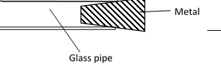

- Form four students were playing football game during which the ball got deflated. Explain what happened to its density (2marks)

- Micrometer screw gauge A has a zero error of – x mm. Micrometer screw gauge B has a zero error of x mm When used to measure the diameter of a tube the difference between their readings is 0.04mm. If the actual diameter of the tube is 5.56mm determinex hence state the reading of micrometer screw gauge A(3 marks)

- A car of mass 1000kg travelling at a constant velocity of 40m/s collides with a stationary metal block of mass 800kg. The impact takes 3s before the two move together. Determine the impulsive force (3marks)

- The figure below shows a drop of water about to fall from a pipette and after falling. Explain why the shapes of the drop are different (2 marks)
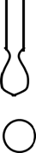
- Figure shows a liquid manometer. The gas pressure is 755mmHg and that of the surround is 760mmHg. The height h is 80mm. Determine the density of the liquid. (Take density of mercury = 13600kgm⁻³ and g =10Nkg⁻¹) (3 marks)
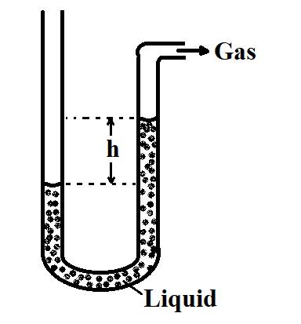
- A student balances a V - shaped uniform wire on a tight string as shown in A and B. With reason state the one which is easier to do (2marks)

- The figure below shows a Bunsen burner. Explain how air is drawn into the burner when the gas tap is opened. (2marks)

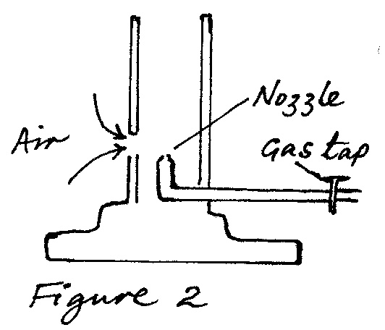

- The figure shows a uniform metal bar of length 10m and weight W = 200N held at equilibrium by a light chain fixed at the cog and tethered on the floor using a light chain. Determine the tension of the chain (3marks)
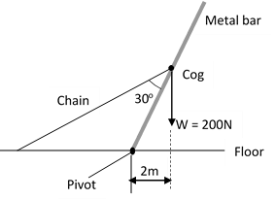
- A student set up the apparatus as shown below. The boiling tube was heated in the middle as shown
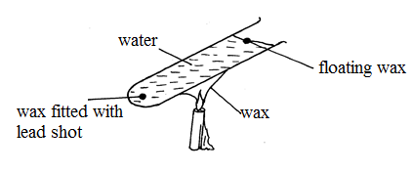
- State the role of the lead shot in the experiment (1mark)

- With reason, state the wax that will melt first (2marks)

SECTION B 55 MARKS: Attempt all the questions in this section

- Marble A is projected horizontally from the top of a cliff at a velocity of 50m/s. The height of the cliff from its foot is 31.25m. At the same time another marble B is projected horizontally from the same point. The figure below shows the trajectories taken by the marbles
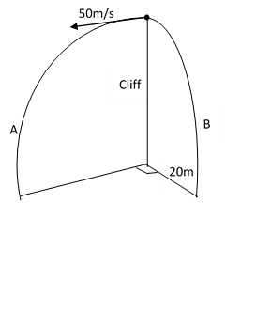

Determine
- The distance of marble A from the foot of the cliff as it hits the ground
(3marks)

- Vertical velocity of marble A as it hits the ground (2marks)

- Horizontal velocity of marble B as it hits the ground (2marks)

- The shortest distance between the marbles upon hitting the ground (2marks)

- The figure below shows two identical light springsand other apparatus used in an experiment
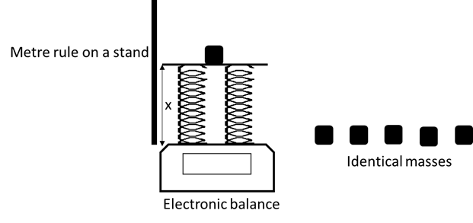
After the data was collected the following graph was obtained
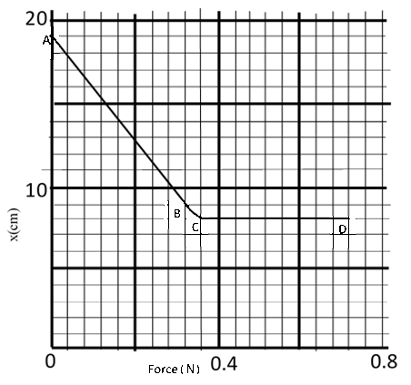
- State two measurements taken in the experiment (2mark)

- Explain how the measurements can be used to come up with the graph (2marks)

- Explain the graph in sections
- AB (2marks)

- CD (2marks)

- Determine the spring constant of each spring (3marks)

- Determine the work done in section CD (2marks)

- On the same axes sketch the graph expected when the experiment is repeated using one of the springs only (1mark)

- The figure below shows an inclined plane on which a trolley of mass 30kg is pulled up a slope by a force of 100N, parallel to the slope. The trolley moves so that its centre of mass travels from points A to B.
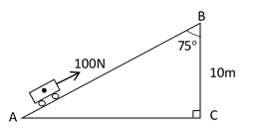

- Determined the work done on the trolley against the gravitational force in moving from A to B. (2 marks)

- Determine the work done by the force in moving the trolley from A to B.
(3 marks)

(iii) Determine the percentage of the work input that goes to waste (3 marks)

- Determine the frictional force. (1 mark)

(v) Determine the mechanical advantage of the system. (1 mark)

(vi) Find the velocity ratio (1 mark)

- a. The figure below shows a set-up that can be used to determine the specific heat capacity of a metal block.
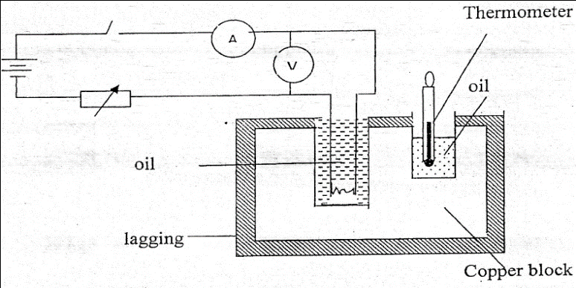

- Other than temperature and current, state two measurements that should be taken in the experiment to determine the specific heat capacity of the block.(2marks)

- Describe how the method can be used to determine the specific heat capacity of the metal block. (3marks)

- State the purpose of oil in the set-up. (1mark)

(ii) A well lagged copper can together with a copper stirrer of total heat capacity 60JK⁻¹ contains 200g of water at 20⁰C. Dry steam at 100⁰C is passed in while the water is stirred until the content reach a temperature of 50⁰C. Determine the mass of condensed steam. (Specific latent heat of vaporization of water is 2.26 X 10⁶ J/kg and specific heat capacity of water is 4200 J/kgK)(4marks)

- a) A uniform metal strip is 3.0cm wide 0.6cm thick and 100cm long. The density of the metal is 2.7g/cm³.
- Determine the weight of the metal strip. (2marks)

The strip is used to support two masses in equilibrium by applying force F as shown below.

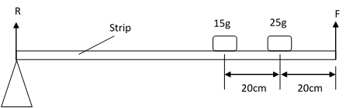

- Determine the value of F (3 marks)

- Determine reaction R due to the pivot (2 marks)

b) The Figure belowshows a set up that may be used to verify a gas law.
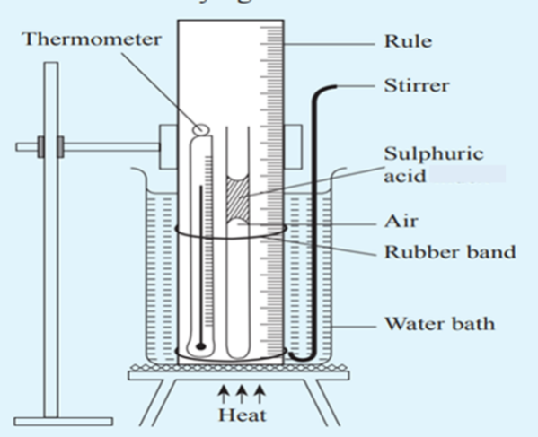

- State the law being verified (1mark)

- State two functions of the concentrated Sulphuric acid in the experiment
(2marks)?

- State one assumption in the experiment (1mark)

THIS IS THE LAST PRINTED PAGE

