CHEMISTRY 233/2
MARKING SCHEME
1. (a) (i) K √1mk
(ii) J or C √1mk
(iii) Group 4 , period i.e. below S in the grid
(iv) J and U are in the same period and across the period the nuclear charge increases hence nuclear
charge of U is greater than that of J hence it pulls the outermost electron more strongly reducing the radius.
(v) Y – is better conductor because it has more delocalized electrons. OR Y- has 3 delocalized
electrons while A how one delocalized electron.
(vi) The B.p of the elements increases √1mk down the group. This is because the intermolecular forces of attraction increase √1mk down the group with increase in the size of the molecules.
(b) (i) V and G√1mk because they are in the same group or loses 2 electrons / some number of electrons in the outer energy levels.
(ii) X, √½mk because its ionic radius is bigger tendency to donate its electron is high. √½mk
(iii) E, √½mk because its ionic radius is bigger than atomic radius so its tendency to donate its electron is high. √½mk
2. (a) Fractional distillation √1mk
(b) (i) Cracking – is the braking of long-chain alkane molecules into shorter alkanes and an alkene by
heating or use of catalyst. √1mk
(ii) - Heat or temperature 400ºC – 700ºC Any two correct for√1mk each
- Silica /SiO₂ or Catalyst – silica /SiO₂
- Aluminium oxide Al₂O₃
(iii) C₁₀H_{22(l)} → C₅H₁₂ + C₅H_{10(g)} √1mk

(iv)
H H H H √½mk
| | |
C = C – C – C – C – H
| | | |
H H H H H Pent-1-ene √½mk
H H H H √½mk
| | |
C = C – C – C – H OR
| |
H H H √½mk
^{H C H}
|
H 2-methyl but- 1-ene
H H H H √½mk
| | |
H C = C – C – C – C – H
| | | |
H H H H H Pent-2-ene √½mk
H H H √½mk
| |
C = C – C – C – H
| |
H H H H √½mk
^{H C H}
|
H 3-methylbut-1-ene
H H H √½mk
| |
H - C = C – C – C – H
| |
H H √½mk
^{H - C - H}
|
H 2-methylbut-2-ene
Any two; drawing ½mk naming ½mk

(v) Shake a sample with;
Bromine C₅H₁₂ does not decolourise, C₅H₁₀ decolourise OR. – Acidified Potassium
chromate (VI) with C₅H₁₂ the orange colour does not change but with C₅H₁₀ the orange
colour changes to green OR Burn a sample of C₅H₁₂ burns with a non-luminous flame;
while C₅H₁₀ burns with luminous
(c) (i) Soapy √1mk Detergent √1mk
(ii) Soapless detergent √1mk because it is non-biodegradable √1mk hence pollutes the
Environment.
3. (a) (i) Name – Aluminium hydroxide √½
Formula: Al(OH)_{3(s)} √½ (1mk)
(ii) Name: Sodium aluminate / tetrahydroxo aluminate √1
Formular: NaAl(OH)_{4(aq)} /[Al(OH)₄]⁻_{(aq)} √1 (2mks)
(b) Amphoterism
(c) Al(OH)_{3(s)} + OH-_{(aq)}→ [Al(OH)₄]⁻_{(aq)} (1mk)

d) i)
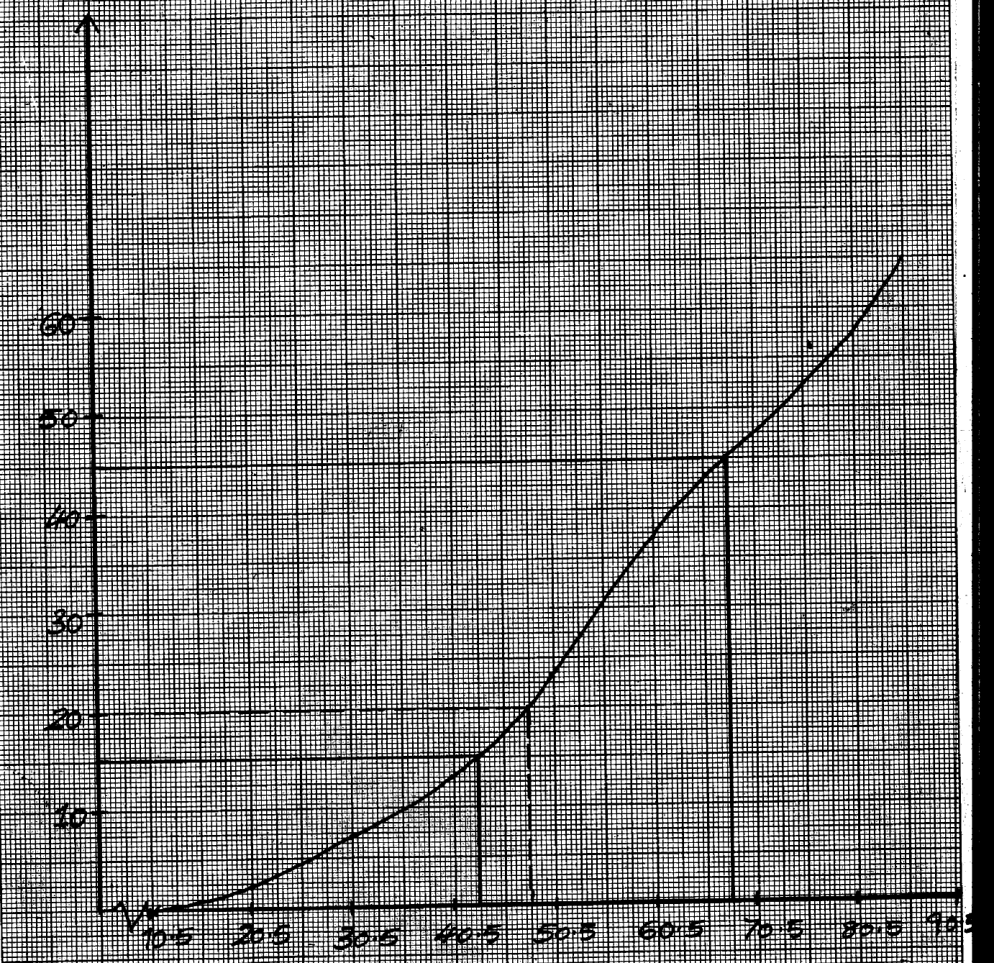

(ii) I . 33/100g of H₂O (must be on the graph)
II. 25ºC √1
III. Solubility of X at 30ºC = ^{19g}/_{100g} of water mass of crystals deposited 50-19 = 31g √½ (1mk)

4. (a) (i) Water
(ii) 6.5; √1 presence of Carbonic acid
i.e CO₂ + H₂O → H₂CO₃
(iii) 2 Na₂O_{2(s)} + 2H₂O_{(l)} →4NaOH_{(aq)} + 2O_{2(s)} √1

(b) (i) to lower the melting point of sodium chloride √1
(ii) sodium react with air and water vigorously/sodium would react with moist air √1

(c) (i) If CO₂ is bubbled in lime water for a few minutes white ppt. is formed. No white ppt. forms
when CO is bubbled into lime water.
(ii) – Extraction of metals √1

(d) CO₂ is highly soluble√½ in sodium hydroxide to form Na₂CO₃ √½soluble in water to form
Carbonic acid. √ (2mks)
5. (a) (i) A – Concentrated hydrochloric acid√1
B – water √ 1mk
(ii) Calcium oxide / CaO√ (1mk)
(iii) To absorb unreacted /excess chlorine √
(iv) 2KMnO_{4(s)} + 16HCl_{(aq)} →2KCl_{(aq)} + 2MnCl_{(aq)} + 8H₂O_{(l)} + 5Cl_{2(g)} √1
(v) Solid C sublimes √ hence collects on a cooler place away fromheating.
(vi) Elements present Al Cl
Mass/volume 0.675 1800cm³
R.A.M/M.G.V 27 24000
No. of moles 0.675 √½ = 0.0025 √½ 1800 = 0.075
27 24100
Mole ratio 0.025 = 1 √½ 0.075 = 3
0.025 0.025
EF = AlCl₃ √½
(AlCl₃)n = 267 √½
(27 + 35.5 x 3 )n = 267
n = 267 =2 √½
133.5
M.F = (AlCl₃)₂ = Al₂Cl₆ √½

(b) (i) 6NaOH_{(aq)} + 3Cl_{2(g) →} NaClO_{3(aq)} + 5NaCl_{(aq) +} 3H₂O_{(l)}
(ii) Bleaching agent in paper pulp√1 // Used as herbicides √1

(c) Sulphur (IV) oxide bleaches by reduction√½ and removal of oxygen from the dye hence
temporary √½ while chlorine bleaches by oxidation√½/adding oxygen to the dye hence permanent. √½

6. A. (i) (a) Carbon (IV) oxide or CO₂ or
Carbon (IV) oxide (CO₂) √1 (Any)

(b) KOH_{(aq)} + CO_{2(g)} KHCO_{3(aq)} √1
Wrong balanced = 0
State symbols wrong or missing ½ mark

(ii) Oxygen gas or O_{2(g)} or oxygen (O₂) gas √1
(iii) Nitrogen gas or N_{2(g)} or nitrogen (N₂) gas. √1

B. (i) Moles of nitrogen = 1.54 √ ½ = 0.11 √ ½
14

Moles of oxygen = 3.53 √ ½ = 0.22 √ ½
16

(ii) N O
Mole ratio 0.11 = 1 √ ½ 0.22 = 2 √ ½
0.11 0.11
Simplest formula NO₂ √1

(iii) Compound has low melting and boiling points √1 because it has a
weak Van der wall forces √1
7. (a) copper oxide / CuO √1mk
(b) CuSO_{4(aq)} + Na₂CO_{3(aq)} CuCO_{3(s)} + Na₂SO_{4(aq)} √1mk
(c) (i) Sodium sulphate / Na₂SO₄ √1mk
(ii) Copper carbonate √1mk
(d) CuO_{(s)} + H₂SO_{4(aq)} CuSO_{4(aq)} + H₂O_{(l)} √1
(e) Cu²⁺ _{(aq)} + CO₃²⁻_{(aq)} CuCO_{3(s)} √1mk5
heat
(f) CuCO_{3(s)} CuO_{(s)} + CO_{2(g)} √1mk
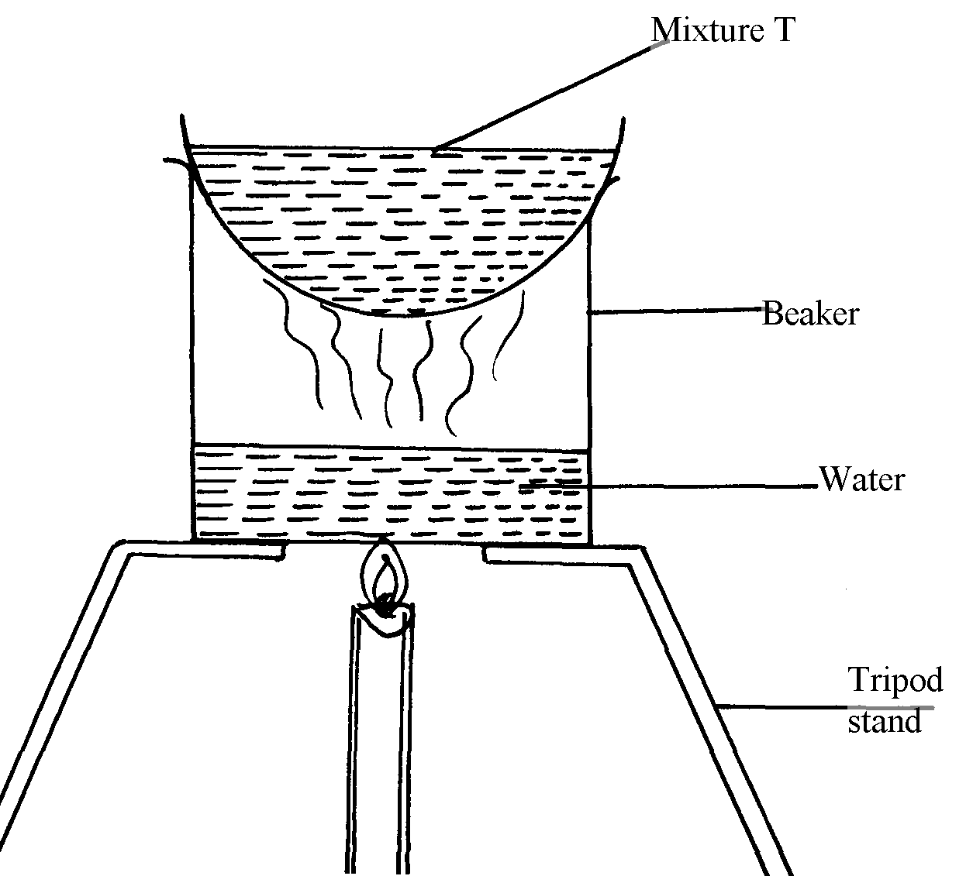
(g) Filtrate √ ½
Beaker √ ½
Water bath√ ½
Tripond stand √ ½
Workability √1mk

