BUNAMFAN CLUSTER EXAMINATION - 2022

Kenya Certificate of Secondary Education
443/1 – AGRICULTURE – Paper 1

June 2022 - 2 hours

Name………………………………………Adm No……
Class…………… Date……………………………

Instructions
This page consists of three sections A, B and C.
Answer ALL the questions in sections A and B and only two questions from section C.
FOR EXAMINERS USE ONLY
SECTION | QUESTION | MAXIMUM  SCORE | CANDIDATE  SCORE
A | 1-15 | 30
B | 16-17 | 20
C | 18-20 | 40

SECTION A (30MKS)
Answer all the questions in this section in the spaces provided.
1. Givefour advantages of large scale farming. (2mks)
………………………………………………………………………………………………………………………………………………………………………………………………………………………………………………………………………………………………………………………………………………………………………………………………………………………………
2a) Define nomadic pastoralism (1mk)
………………………………………………………………………………………………………
b) State two advantages of nomadic pastoralism. (1mk)
………………………………………………………………………………………………………………………………………………………………………………………………………………
3. Statefour factors which determine soil depth. (2mks)
………………………………………………………………………………………………………………………………………………………………………………………………………………………………………………………………………………………………………………………………………………………………………………………………………………………………
4. Givefour natural factors that would encourage the gully erosion on a farm. (2mks)
………………………………………………………………………………………………………………………………………………………………………………………………………………………………………………………………………………………………………………………………………………………………………………………………………………………………

5. Statefour ways in which trees help in soil conservation. (2mks)
………………………………………………………………………………………………………………………………………………………………………………………………………………………………………………………………………………………………………………………………………………………………………………………………………………………………
6. Statefour disadvantages of communal land tenure system. (2mks)
………………………………………………………………………………………………………………………………………………………………………………………………………………………………………………………………………………………………………………………………………………………………………………………………………………………………
7. Statefour factors that should be considered when selecting a forage crop species to be established in a given area. (2mks)
………………………………………………………………………………………………………………………………………………………………………………………………………………………………………………………………………………………………………………………………………………………………………………………………………………………………
8. What do you understand by the following terms. (3mks)
Seed dressing
………………………………………………………………………………………………………
Seed inoculation
………………………………………………………………………………………………………
Chitting
………………………………………………………………………………………………………

9. Givetwo advantages of compound fertilizers (1mk)
………………………………………………………………………………………………………………………………………………………………………………………………………………
10. Statetwo effects of varying spacing in maize production. (2mks)
………………………………………………………………………………………………………………………………………………………………………………………………………………
11. Statefour symptoms of viral diseases in crop production. (2mk)
………………………………………………………………………………………………………………………………………………………………………………………………………………………………………………………………………………………………………………………………………………………………………………………………………………………………
12. Listfour branches of livestock farming. (2mks)
………………………………………………………………………………………………………………………………………………………………………………………………………………………………………………………………………………………………………………………………………………………………………………………………………………………………
13. Namefour varieties of dry beans (2mks)
………………………………………………………………………………………………………………………………………………………………………………………………………………………………………………………………………………………………………………………………………………………………………………………………………………………………

14. Givefour precautions taken to prevent pest attack in stored produce. (2mks)
………………………………………………………………………………………………………………………………………………………………………………………………………………………………………………………………………………………………………………………………………………………………………………………………………………………………
15. What is organic farming? (1mk)
………………………………………………………………………………………………………
SECTION B (20MKS)
16. Study the diagrams below carefully and answer the questions that follow.
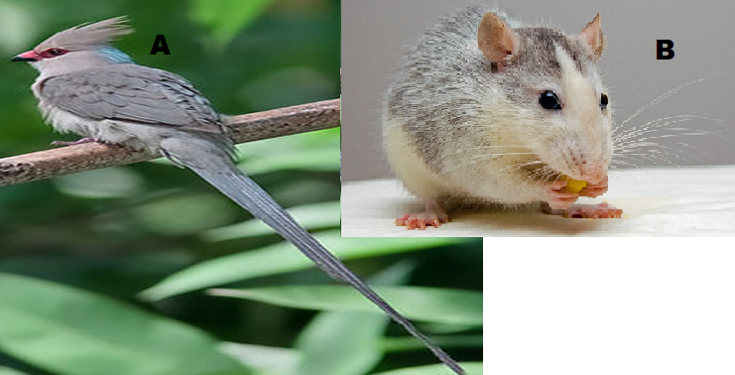
a)Identify the pests labelled A and B (2mks)
………………………………………………………………………………………………………
b) Statetwoaffects the pest labelled A causes on a maize plant. (2mks)
………………………………………………………………………………………………………………………………………………………………………………………………………………c) Listthree effects of pest B in stores. (3mks)
………………………………………………………………………………………………………………………………………………………………………………………………………………………………………………………………………………………………………………………
d)State three methods of controlling striga weed. (3mks)
………………………………………………………………………………………………………………………………………………………………………………………………………………………………………………………………………………………………………………………
17.The diagram below shows a field management practice carried out on a fruit crop.Study it carefully and answer the question that follow.
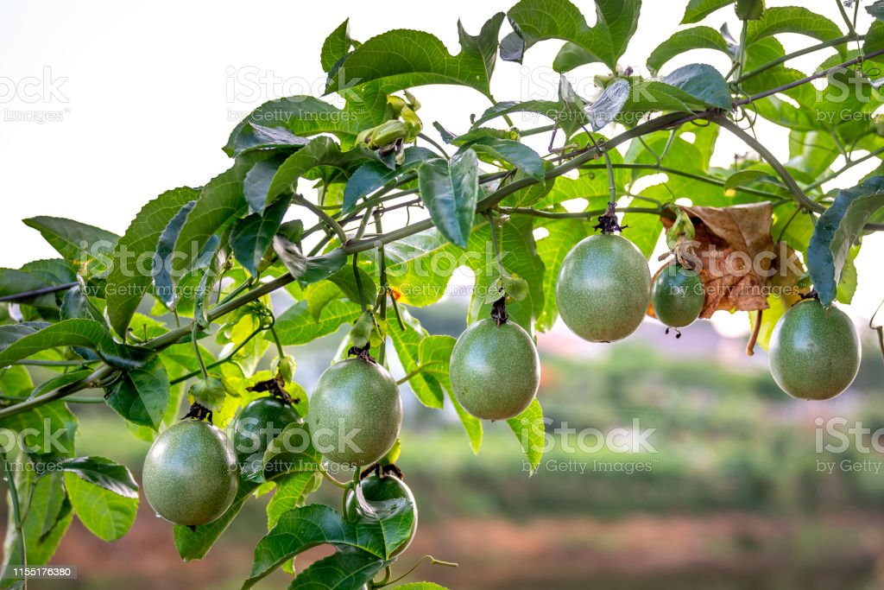

a) Identify the practice (1mk)
………………………………………………………………………………………………………
b) Givetwo reasons for carrying out the above practice. (2mks
………………………………………………………………………………………………………………………………………………………………………………………………………………c) Statethree reasons for storing beans after harvesting. (3mks)
………………………………………………………………………………………………………………………………………………………………………………………………………………………………………………………………………………………………………………………

d) Statethree advantage of processing farm produce. (3mks)
………………………………………………………………………………………………………………………………………………………………………………………………………………………………………………………………………………………………………………………
e) Define the term drainage. (1mk)
………………………………………………………………………………………………………
SECTION C (40MKS)
Answer any two questions from this section in the spaces provided.
18a) Describe eight farming activities that would encourage soil erosion (8mks)
………………………………………………………………………………………………………………………………………………………………………………………………………………………………………………………………………………………………………………………………………………………………………………………………………………………………………………………………………………………………………………………………………………………………………………………………………………………………………………………………………………………………………………………………………………………………………………………………………………………………………………………………

b) Describe the harvesting of cotton. (8mks)
………………………………………………………………………………………………………………………………………………………………………………………………………………………………………………………………………………………………………………………………………………………………………………………………………………………………………………………………………………………………………………………………………………………………………………………………………………………………………………………………………………………………………………………………………………………………………………………………………………………………………………………………
c) Describe seedbed preparation for carrot production. (4mks)
………………………………………………………………………………………………………………………………………………………………………………………………………………………………………………………………………………………………………………………………………………………………………………………………………………………………

19a) Describeten factors that would determine the nutrient content of hay. (10mks)
………………………………………………………………………………………………………………………………………………………………………………………………………………………………………………………………………………………………………………………………………………………………………………………………………………………………………………………………………………………………………………………………………………………………………………………………………………………………………………………………………………………………………………………………………………………………………………………………………………………………………………………………………………………………………………………………………………………………………

b)Describe ten advantages of using organic matter for mulching. (10mks)
………………………………………………………………………………………………………………………………………………………………………………………………………………………………………………………………………………………………………………………………………………………………………………………………………………………………………………………………………………………………………………………………………………………………………………………………………………………………………………………………………………………………………………………………………………………………………………………………………………………………………………………………………………………………………………………………………………………………………………………………………………………………………………………………………………

20a)Explain six morphological features of weeds that influence selectivity of herbicides.(6mks)
………………………………………………………………………………………………………………………………………………………………………………………………………………………………………………………………………………………………………………………………………………………………………………………………………………………………………………………………………………………………………………………………………………………………………………………………………………………………………………………………………………………………………………………………………………………………………………………………………………………………………………………………
b)Give five disadvantages of zero grazing system. (5mks)
………………………………………………………………………………………………………………………………………………………………………………………………………………………………………………………………………………………………………………………………………………………………………………………………………………………………………………………………………………………………………………………………………
c)Describe nine factors considered in the selection of planting materials. (9mks)
………………………………………………………………………………………………………………………………………………………………………………………………………………………………………………………………………………………………………………………………………………………………………………………………………………………………………………………………………………………………………………………………………………………………………………………………………………………………………………………………………………………………………………………………………………………………………………………………………………………………………………………………
THIS IS THE LAST PRINTED PAGE

