BUNAMFAN CLUSTER EXAMS 2020
Kenya Certificate of Secondary Education
232/2 − PHYSICS −Paper2 -marking scheme
FORM 4 TERM 1 JUNE 2022- 2 HOUR
Name…………….………………….…………………Adm.no……:… School………….

Candidate’s Signature…………………………………………. Date………………………...…

Instructions to Candidates

- Write your name and index number in the spaces provided above.
- Sign and write the date of examination in the spaces provided above.
- This paper consists of two sections: A and B.
- Answer ALL the questions in sections A and B in the spaces provided.
- ALL working MUST be shown clearly
- Mathematical tables and silent electronic calculators may be used.
- This paper consists of 14 printed pages.
- Candidates should check the question paper to ascertain that all the pages are printed as indicated and that no questions are missing.

For Examiner’s Use Only

SECTION | QUESTION | MAXIMUM SCORE | CANDIDATE’S SCORE
A | 1 – 13 | 25
B | 14 | 11
 | 15 | 12
 | 16 | 0 9
 | 17 | 11
 | 18 | 12
TOTAL SCORE |  | 80

SECTION A (25 MARKS)

Answer ALL the questions in this section in the spaces provided

- (a)Distinguish between real and virtual Image (1mk)
Real image is formed by intersection of real rays while virtual image is formed by intersection of virtual rays ✓OR
A real image is one that can be focused on a screen while a virtual image is one that cannot be focused on a screen ✓
b) A pinhole camera forms an image of size 10cm. The object is 5m tall and 20m away from the pinhole. Find the length of the pinhole camera. (2mks

^{v}/₂₀₀₀=¹⁰/₅₀₀✓
=40cm or 0.4m✓

2.Why is it safer to carry explosive fuels in metal cans instead of plastic can? (1mark)
Metal tanks can be earthed thus discharging preventing explosion, the plastic tank would insulate thus leading to build up of charges that can lead to explosions. ✓

3.The figure 1 below shows a cross section of a dry cell.
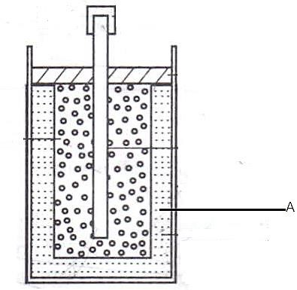Figure 1
  - Name the part labeled A (1 mark)
Ammonium chloride paste
  - State the use of manganese (iv) oxide in the cell (1 mark)
-Acts as depolarizer/ oxidizing agents✓

4.a) The figure 2 below shows a soft iron bar that’s placed in a coil near a free suspended magnet.

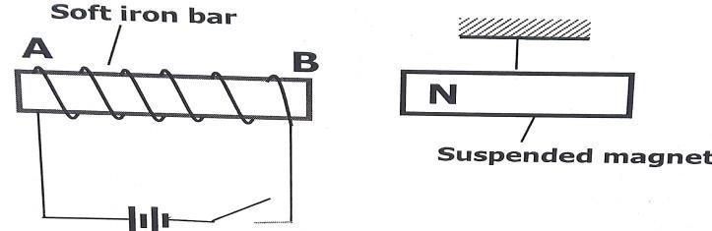 figure 2
State and explain the observation made when the switch is closed. (2marks)
Suspended magnet is repelled /moved away from the electromagnet. ✓
Reason; current flows making soft iron bar to be electromagnet acquiring north pole at B hence repulsion✓

b.) Give a reason why attraction in magnetism is not regarded as a reliable method of testing for polarity. (1mark)
-Occurs either between unlike poles of a magnet or between a magnet and a magnetic material✓
5.Explain the term wavelength in terms longitudinal wave (1mark)
It is the distance between two successive crests or troughs in a transverse wave or the distance between two successive rarefactions or compressions in a longitudinal wave. ✓
6.(a) State the effect of pressure on the speed of sound in air. (1mk)
No effect✓
(b) A boy stands 190m from a high wall and claps his hands. If he hears an echo1.3 Seconds later, calculate the speed of sound in air. (2mks)

V=^{2d}/_{t}
=^{2*190}/_{1.3}✓
= 292.3m/s✓

7.Figure 3 below shows an object, O placed 10 cm in front of a concave mirror whose radius, C is 40 cm.

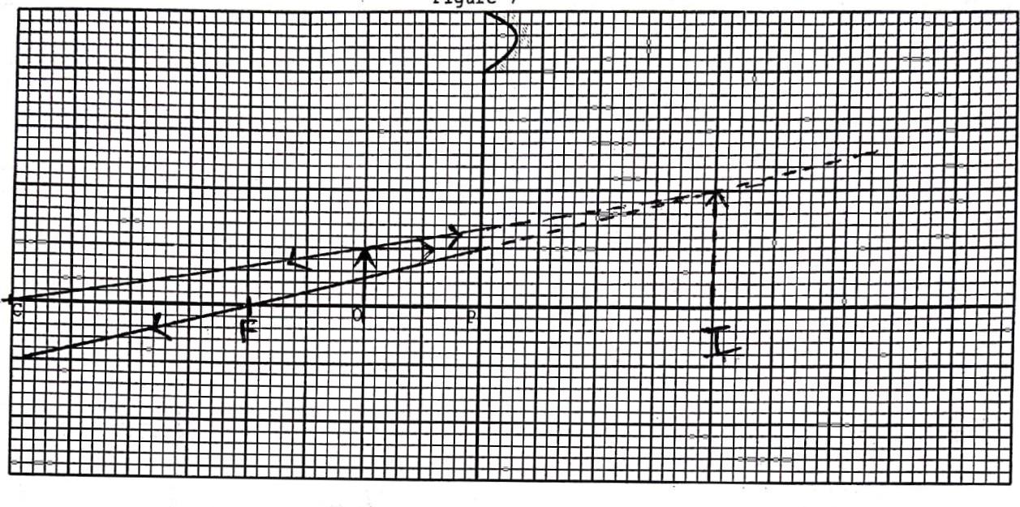 Figure 3
On the same figure, draw a ray diagram to show the position of the image formed. (3 mks)

8.State any factor that determine the heating effect by an electric current.
(1mark)
-Resistance✓
-Time of heating✓
- Current✓
8 . Figure 4 shows the table of electromagnetic. Spectrum in the increasing order of wavelengths.

P | x-rays |  | Q | Infra-red
Figure 4
a).Identify the radiation marked (1mark) Q. –visible light✓
b) State the application of radiation marked P (1mark
sterilize medical equipment ✓

10.Light travels from glass to air as shown in Figure 5. The refractive index of glass 1.5

X
0

Air

Glass

n=5

Figure 5
(a) Determine angle x (2marks)
Sin X 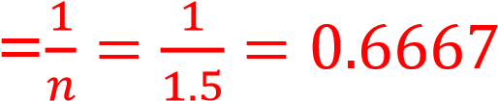 ✓
X=41.81˚✓

11. . Figure 6 shows air molecules in front of a hollow, wooden box B set vibrating by a tuning fork.
Tuning fork

Figure 6 Y Z
i) State the reason of mounting the tuning fork on the box which is open at one
end.  To produce a coherent source of vibration✓ | (1mark)
ii) What is the name given to this kind of wave?  Longitudinal wave ✓ | (1mark)

12.The figure7 below shows an isolated negative charge placed closer to a negatively charged plate. Draw the electric field patterns. (1mark)

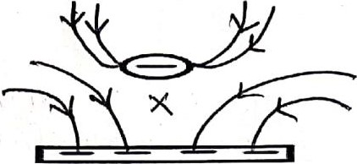

figure7
13. Kenya launched the use of optical fibres in communication recently. State why optical fibres are preferred to ordinary cables.
Because they have higher carrying capacity than ordinary cables✓.

SECTION B( 55MARKS)

14. (a)State two ways in which the speed of rotation of a motor can be increased (2marks)
Winding the coil on a soft iron core. ✓
Increasing the number of turns of the rotating coil. ✓
Using a stronger magnet ✓
Multiplying the number of coils and commuter segments ✓

b The figure 8 below shows a simple electric bell circuit
Switch

figure 8 Y
Gong

X

Hammer

Spring

Z

N

S

i) Name the parts labeled. (2mark)
- X Soft iron core ✓
- Y Soft iron armature ✓
ii) When the switch is closed, the hammer hits the gong repeatedly. Explain why:
- The hammer hits the gong. (2mk)
When the switch S is closed, the current flows through the circuit and the core becomes magnetised, ✓ the electromagnet induces magnetism in the soft iron strip (armature), which is then attracted to the poles of the electromagnet. The hammer attached to the armature thus strikes the gong. ✓

- The hammer hits the gong repeatedly (2mk)
The attraction of the soft iron armature separates the contacts breaking the circuit. The magnetism in the core therefore dies off ✓ and the spring returns the armature to its original position. Contact is made again and the process is repeated.So long as the switch is closed, the hammer strikes the gong repeatedly. ✓
iii) If the armature is made of steel metal, it is observed that the bell will take to ring. Explain this observation . (1 mark)

Steel metal takes much time to be magnetized ✓

iv) Name two adjustment should be done to the system to make it operate effectively with a lower voltage battery? (1mk)
-Reducing the contact space between the contact screw and the steel spring✓
-Increase the number of turns

15. (a) In an experiment to determine the internal resistance of a cell, the following circuit was used.
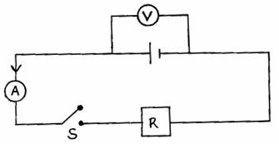

It was noted that when S is open, the voltmeter reads 1.5V and when S is closed the voltmeter reads 1.3V and ammeter reads 0.2A.
(i) What is e.m.f of the cell. (1mark)
1.5v

(ii) Determine the lost voltage. (1mark)
1.5 - 1.3 = 0.2v

(iii)Determine the value of R. (2marks)
V = IR
1.3 = 0.2R
R = $\frac{1.3}{0.2}$ = 6.5Ω

(iv) Determine the internal resistance of the cell. (3marks)
E = 1 (R + r)
1.5 = 0.2 (6.5 + r)
1.5 = 1. 3 + 0.2r
0.2r = 0.2
R = 1 Ω

- Study the circuit below and answer the questions that follow.
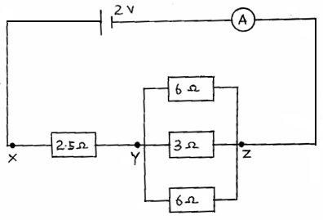

(i) Determine the effective resistance of the circuit. (3marks)

1 = 1 + 1 + 1
R_{T} R₁ R₂ R₃

= $\frac{1}{6}$ + $\frac{1}{3}$ + $\frac{1}{6}$ = $\frac{1 + 2 + 1 }{6}$ = $\frac{4}{6}$
R = $\frac{6}{4 }$ = 1.5
R_{T} = 1.5 + 2.5 = 4 Ω

(ii) Find the p.d between X and Y. (2marks)

V = IR
I = $\frac{2}{4}$ = 0.5 A

V = IR
= 0.5 x 2.5
= 1.25 v

16.(a) (i)Define capacitance of capacitor (1mk)
Capacitance is the ratio of charge stored on the plate to the potential difference between the plate. ✓

(ii)A positively charged rod with a pointed end is brought near a candle flame as shown in figure 9
Flame
figure 9

Candle

Positively
charged needle

Explain why the flame burns in the direction shown (1mk)
The negative ions in the flame are attracted to the rod, diverting part of the flame towards it. At the same time, positive ions are repelled away diverting part of the flame away✓.
b)One of the factors which affect the capacitance of a parallel plate capacitor is the area of overlap of the plates. Name two other factors. (2mks)
Distance of separation✓.
  Nature of the dielectric materials. ✓
c).Calculate the effective capacitance of the capacitors shown across points X and Y. (3mks)
60µF 30µF

X

Y

20
µF

C_{S}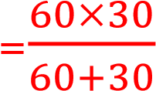 ✓

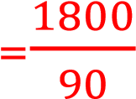
=20 μF ✓
C_{T}=20 μF +20 μF
=40 μF ✓

d).A capacitor was full charged to a potential of 40v. The capacitor is connected as
shown in the figure below to discharge at load resistor R. Sketch a graph to show how
the capacitor discharges with time

(2
mks
)

R

A

V

Voltage (V)

Times (s)

17.a Water waves from a given source move from a deeper a shallow to end. What effect would this have on the;
(i) Frequency (1mk)
Frequency remains constant
(ii) Wavelength (1mk)
Decreases
(iii) Velocity of the wave
Decreases
bThe figure 10 shows wave fronts approaching a wide opening

figure 10

  - Complete the diagram to show the appearance of the wave fronts after crossing the opening (2mk)
  - State what would be observed on the pattern if the gap was made smaller Circular waves would be observed after the slit.

c.) Figure11 below shows light rays from two coherent sources S₁ and S₂ falling on screen. Dark and bright fringes are observed between A and B

Figure11 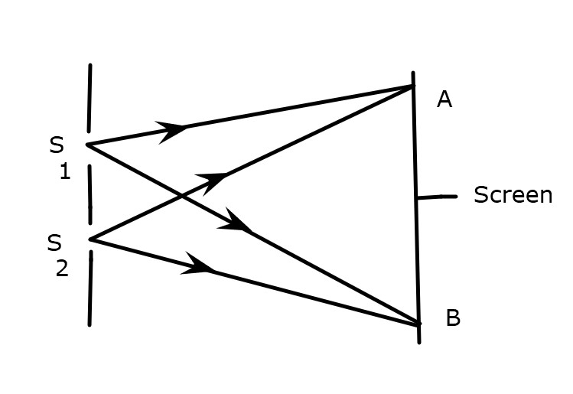

- State the function of S₁ and S₂ (1mk)

To act as coherent source of light waves that causes interference.

- State how
- Bright fringes are formed (1mk)
Due to constructive interference / when the two crest or troughs meet

- Dark fringes are formed (1mk)
Due to destructive interference / when the crest and troughs of two waves meet

c). Figure12 below shows plane water waves incident on a plane reflector placed at an angle to the path of the waves.
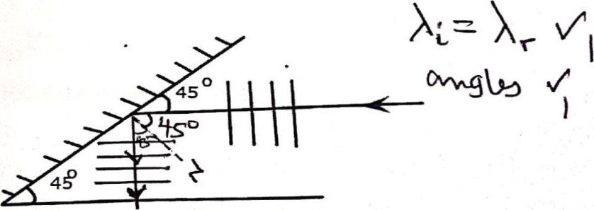
Figure12
Complete the diagram to show the reflected waves (2mks)

18. (a) Define principal focus for convex lens(1mark)

This is a point on the principal axis for a convex lens that all the rays seem to converge.

b) Sketch on a diagram to illustrate how a convex lens is used as a magnifying
glass. (3 marks)
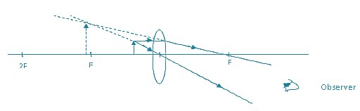

(c) In an experiment to determine the focal length of a converging lens using lens
formula, several values of image distance corresponding to value of object distance u
were determined and a graph of magnification m against image distance
v, plotted as shown in Figure 13

Figure 13

The equation of the graph can be represented by the equation

m=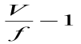

(i) State the significance gradient of the graph . (1mk)

Reciprocal of forces length /power of the lens
(ii) From the graph, determine the focal length of the lens. (3mks)

Gradient = $\frac{1}{f}$
G = 1.0__ = 0.1
20-10

$\frac{1}{f}$ = 0.1
f = $\frac{1}{0.1}$ = 10 cm

(iii) Determine the value of object distance for which the image is not magnified. (1mk)

V = u = 20cm (when m = 0)

(iv) An object of height 10.5cm stands before a diverging lens of focal length 20cm and a
distance of 10cm from the lens. Determine the image distance. (3 marks)

$\frac{1}{f}$ = $\frac{1}{u}$ + $\frac{1}{v}$ f = - 20 cm
u = + 10cm

$\frac{1}{v}$ = $\frac{-1}{f}$ - $\frac{1}{v}$

= $\frac{1}{20}$ - $\frac{1}{10}$ = $\frac{-1-2}{20}$ = $\frac{-3}{20}$
V = 6.667 cm

