**BUNAMFAN CLUSTER EXAMINATION - 2022**

**Kenya Certificate of Secondary Education**

**231/1 – BIOLOGY – Paper 1**

**June 2022 - 2 hours**

**Name**………………………………………**Adm No**……

**Class**…………… **Date**……………………………

**INSTRUCTIONS TO CANDIDATES:**

Write your **Name, Class** and **Adm NO** in the spaces provided above.

Answer **all** the questions in this paper in the spaces provided.

**FOR EXAMINER’S USE ONLY:**

|  |  |  |
| --- | --- | --- |
| **Question** | **Maximum**  **Score** | **Candidate’s**  **Score** |
| **1 - 27** | **80** |  |

**attempt all the questions**

1. Some form one students wanted to collect the following animals for study in the laboratory. **State** the suitable apparatus they should use.

i) Housefly (1 mk)

……………………………………………………………………………………………………..

ii) Scorpion (1 mk)

. ..........................................................................................................................................................

iii) Ants (1 mk)

………………………………………………………………………………………………….......

2. State **two** reasons why a snake is classified as a reptile. (2 mks)

........................................................................................................................................................................................................................................................................................................................................................

3. (a) **Explain** the role of oxygen in Active transport (1mk)

……………………………………………………………………………………………………………………………………………………………………………………………………………………………………

(b) Name **two** processes that depend on Active transport in animals (2mks)

…………………………………………………………………………………………………………………

…………………………………………………………………………………………………………………

............................................................................................................................................................................

4. **Explain** how sunken stomata lower the rate of transpiration (2mks)

…………………………………………………………………………………………………………………

…………………………………………………………………………………………………………………

5. **State** how xylem vessel is adapted to its function (3mks)

…………………………………………………………………………………………………………………

…………………………………………………………………………………………………………………

…………………………………………………………………………………………………………………

6). a) **Define** the term immunity. (1mk)

…………………………………………………………………………………………………………………

……………………………………………………………………………………………………......

b) **Distinguish** between natural immunity and acquired immunity. (1mk)

……………………………………………………………………………………………………………..…

………………………………………………………………………………………………………….

c) Identify **one** immunizable disease in Kenya. (1mk)

……………………………………………………………………………………………………………….

7. (a) State **two** adaptations of the alveolus to its functions. (2mks)

…………………………………………………………………………………………………………………

………………………………………………………………………………………………………………..

1. **Sugges**t a reason for asthmatic patient producing a wheezing sound during breathing? (1mk)

.........................................................................................................................................................................

(c) **What** is the significance of the cartilage found in the human trachea being incomplete (c- shaped rings) (1mk)

........................................................................................................................................................................

8. **Define** the following terms;

(i) Inter specific competition. (1mk)

......................................................................................................................................................................

(ii) Carrying capacity (1mk)

…………………………………………………………………………………………………………………

………………………………………………………………………………………………………….....

9. Suggest **two** methods that can be used to determine the type of food eaten by animals. (2mks)

…………………………………………………………………………………………………………………

…………………………………………………………………………………………………………………

10. (a) State **one** significance of genetics counseling (1mk)

.....................................................................................................................................................................

(b) Part of a strand of DNA molecules was found to have the following sequence

A-T-C-G-G-G-A-T-C-T. What is the sequence?

(i) Of the complementary strand? (1mk)

……………………………………………………………………………………………………………

(ii) On a m- RNA strand copied (1mk)

……………………………………………………………………………………………………………

11). The paddles of whales and the fins of fish adapt these organisms to aquatic habitats.

a) **Name** the evolutionary process that may have given rise to these structures. (1mk)

.......................................................................................................................................................................

b) What is the **name** given to such structures? (1mk)

……………………………………………………………………………………………………………..

c) Give **two** examples of vestigial organs in man. (2mks)

………………………………………………………………………………………………………………

.......................................................................................................................................................................

12. Name the organelles that carry out the following functions (4mks)

1. Destroy old and worn-out organelles

…………………………………………………………………………………………………

1. Formation of spindle fibres

…………………………………………………………………………………………………

1. Osmoregulation

…………………………………………………………………………………………………

1. Selective passage of substances into the cell

…………………………………………………………………………………………………

13. (a) Why would you give an athlete glucose and not sucrose after a race? (1mk)

……………………………………………………………………………………………………………………………………………………………………………………………………

(b) What happens to lactic acid after oxygen debt recovery? (2mks)

…………………………………………………………………………………………………………………………………………………………………………………………………..

14.**State** the difference between glycolysis and kreb”s cycle based on the following.

a) where they occur . ( 1 mk)

………………………………………………………………………………………………

b) Amount of energy produced. ( 1 mk)

………………………………………………………………………………………………

c) End product(s) (1 mk )

……………………………………………………………………………………………..

15. a) Under which of the following magnifications would one see a larger part of the specimen X40 0r X500? Give a reason. (2 mks)

……………………………………………………………………………………………………………………………………………………………………………………………………………………………………b) State how magnification is worked out in a light microscope. (1 mk)

……………………………………………………………………………………………………………………………………………………………………………………………………………………………………

16. The illustration below shows a transverse section through a mammalian kidney.

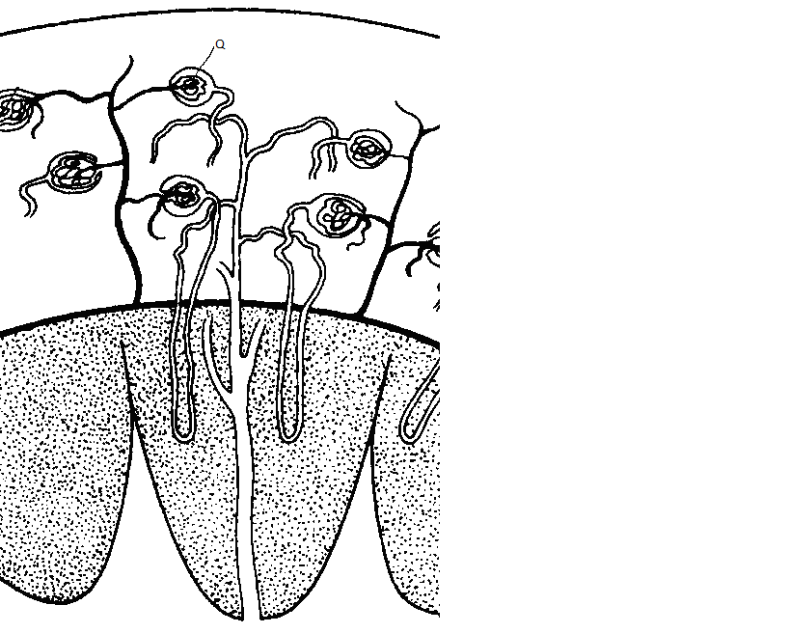

**Y**

**X**

(a) **Name** the structures labelled **X** and **Y**.

**X** ………………………………………………………………………………………………… ( 1mk)

**Y** ………………………………………………………………………………………………… (1mk)

(b) **State** the process in **Q** that leads to the formation of glomerular filtrate. (1mk)

......................................................................................................................................................................

c) State one function of sebum (1 mk)

……………………………………………………………………………………………………………………………………………………………………………………………………………………………………

17. State **three** differences in composition between umbilical artery and umbilical vein. (3 marks)

|  |  |
| --- | --- |
| **Umbilical vein** | **Umbilical artery** |
|  |  |
|  |  |
|  |  |

18. (a)**What** is meant by the term taxonomy? (1mk)

……………………………………………………………………………………………………………..

(b)**When** are two organisms considered to belong to the same species. (2mks)

…………………………………………………………………………………………………………………

…………………………………………………………………………………………………………………

19).The diagram below shows part of alimentary canal of a mammal

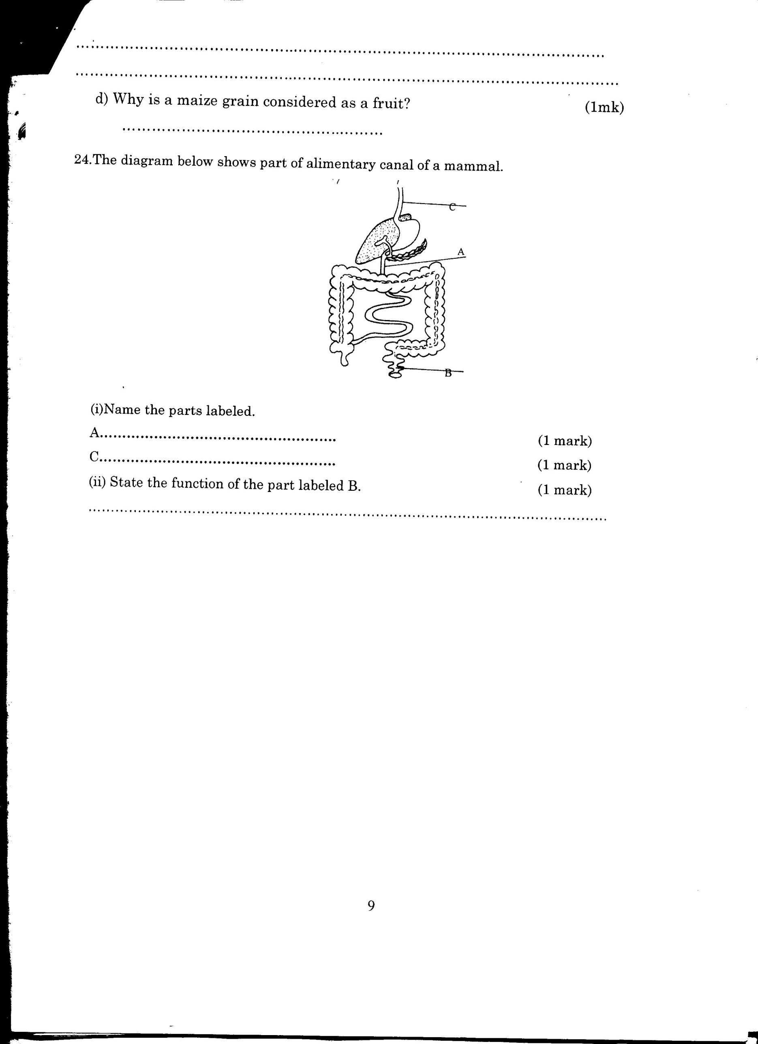

(i)**Name** the parts labeled **A** and **C** (2mks)

**A** …………………………………………………………………………………………

**C** ………………………………………………………………………………………….

(ii)**State** the function of the part labeled **B.**  (1mk)

............................................................................................................................................................................

............................................................................................................................................................................

20). The graph below shows the relationship between body temperatures and external temperatures in a human being and a snake. **Study** it and answer questions that follow.

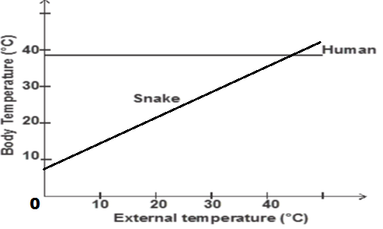

 a**) What** happens to the temperature of each organism as the external temperature increases. (2 mks)

Human –……………………………………………………………………………………………………

Snake –.........................................................................................................................................................

**b)** Humans are described as homoithermic. **State** the advantage of this condition. (2mks)

*..........................................................................................................................................................................*

*............................................................................................................................................................................*

21.**a)**State **three** differences between light stage and dark stage of photosynthesis. (3 mks)

|  |  |
| --- | --- |
| **Light stage** | **Dark stage** |
|  |  |
|  |  |
|  |  |

 22. Define;

i) Pulmonary circulation (1mk)

................................................................................................................................................................

................................................................................................................................................................

ii) Systemic circulation (1mk)

................................................................................................................................................................

................................................................................................................................................................

23 **.**The diagram below represents a plant cell that was subjected to a certain treatment.



**At the start At the end of the experiment**

**a) Account** for the shape of the cell at the end of the experiment. (2 mks)

......................................................................................................................................................................

............................................................................................................................................................................

............................................................................................................................................................................

**b)** **Draw** a diagram to illustrate how an animal cell would appear if subjected to the same treatment. (1mk)

24. a) **Give** a reason why each of the following steps are followed when preparing cross sections of a leaf for examination under a microscope.

i) Cutting thin sections. (2 mk)

**………………………………………………………………………………………………………………..**

ii) Placing the sections in water. (1 mk)

...........................................................................................................................................................................

25. Explain **why** the population of people with sickle cell anaemia is higher in malaria prone areas. (3mks)

…………………………………………………………………………………………………………………

…………………………………………………………………………………………………………………

…………………………………………………………………………………………………………………

26. The diagram below is of a stage in cell division

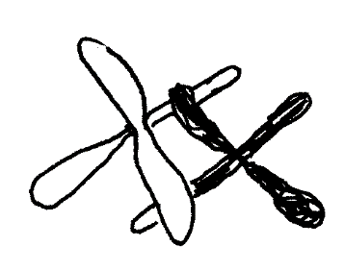

With a reason identify the stage.

Stage (1 mk)

…………………………………………………………………………………………………………

Reason (1 mk)

……………………………………………………………………………………………………………………………………………………………………………………………………………………

1. The graph below represents growth pattern in a group organism

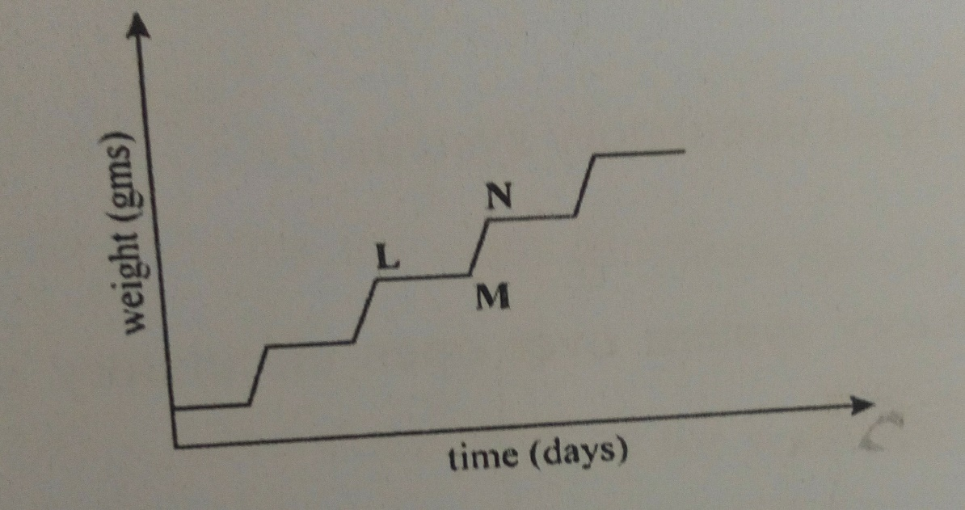

1. Name the type of growth curve (1 mk)

……………………………………………………………………………………………………

1. Name the phylum that shows this type of pattern (1 mk)

……………………………………………………………………………………………………

1. State one disadvantage of this type of pattern (1 mk)

……………………………………………………………………………………………………

**THIS IS THE LAST PRINTED PAGE**